ABSTRACT
SajiloWear is an online platform that makes traditional Nepali attire more affordable, accessible, and sustainable through a rental and sharing model with integrated payment support. Users can browse ethnic clothing collections, check availability, rent or share attire, complete payments, and manage their profiles, while attire owners can upload outfits, set prices, receive payment confirmation, and approve rental requests. The platform ensures a smooth, secure, and community driven experience for cultural clothing rentals. By promoting reuse of traditional garments, SajiloWear helps reduce wardrobe waste, preserve Nepali culture, and encourage eco friendly fashion practices. The platform is built using PHP for backend processing, MySQL for data management, and HTML, CSS, and JavaScript for a responsive and user friendly interface, running on XAMPP as a local development server.
Keywords: Nepali attire rental, cultural preservation, peer to peer sharing, sustainable fashion, online payment, PHP, MySQL

LIST OF FIGURES
Figure 1.1: Iterative Waterfall Model ............................................................................. 10
Figure 3.1: Use Case Diagram ....................................................................................... 15
Figure 3.2: ER Diagram ................................................................................................. 18
Figure 3.3: Class Diagram ............................................................................................. 19
Figure 3.4: Sequence Diagram of Admin ...................................................................... 21
Figure 3.5: Sequence Diagram of User ......................................................................... 22
Figure 3.5: Activity Diagram ......................................................................................... 23

LIST OF TABLES
Table 1: Gantt Chart ................................................................................................. 17

LIST OF ABBREVIATIONS
CRUD : Create, Read, Update, Delete
PHP : Hypertext Preprocessor
MySQL : My Structured Query Language
HTML : Hypertext Markup Language
CSS : Cascading Style Sheets
JS : JavaScript
XAMPP : Cross-Platform Apache, MariaDB, PHP, Perl package

TABLE OF CONTENTS
ABSTRACT ........................................................................................................................ ii
LIST OF FIGURES ............................................................................................................ iii
LIST OF TABLES ................................................................................................................. iv
LIST OF ABBREVIATIONS .................................................................................................. v
CHAPTER 1............................................................................................................................ 1
INTRODUCTION.................................................................................................................... 1
1.1 Introduction ................................................................................................................... 1
1.2 Problem Statement ........................................................................................................ 1
1.3 Objectives ..................................................................................................................... -2-
1.4 Scope and Limitations ................................................................................................... -2-
1.5 Development Methodology ........................................................................................... -2-
CHAPTER 2............................................................................................................................-5-
BACKGROUND STUDY AND LITERATURE REVIEW ...................................................- 5-
2.1 Background Study .........................................................................................................-5-
2.2 Literature Review ..........................................................................................................- 6-
CHAPTER 3: SYSTEM ANALYSIS AND DESIGN .........................................................-8-
3.1 System Analysis ........................................................................................................... -8-
3.1.1 Requirement Analysis ............................................................................................ -8-
i. Functional Requirements .......................................................................................... -8-
ii. Non-Functional Requirements ................................................................................ -10-
3.1.2 Feasibility Study ................................................................................................... -10-
i. Technical Feasibility ................................................................................................. -10-
ii. Operational Feasibility ........................................................................................... -11-
iii. Economic Feasibility ............................................................................................. -11-
iv. Schedule Feasibility ................................................................................................ -11-
3.1.3 Class Diagram ....................................................................................................... -13-
3.1.4 Sequence Diagram ................................................................................................ -14-
3.1.5 Activity Diagram .................................................................................................... -16-
3.2 System Design ............................................................................................................. -17-
3.2.1 Component Diagram .............................................................................................. -17-
3.2.2 Deployment Diagram ............................................................................................. -18-
CHAPTER 4..........................................................................................................................-19-
IMPLEMENTATION AND TESTING ............................................................................... -19-
4.1 Implementation ............................................................................................................ -19-
4.1.1 Tools Used ............................................................................................................. -19-
4.2 Testing ......................................................................................................................... -19-
4.2.1 Unit Testing ............................................................................................................. -20-
4.2.2 System Testing ........................................................................................................ -23-
CHAPTER 5......................................................................................................................... -24-
CONCLUSION AND FUTURE RECOMMENDATION ................................................... -24-
5.1 Conclusion ................................................................................................................... -24-
5.2 Lesson Outcomes ........................................................................................................ -24-
5.3 Future Recommendation .............................................................................................. -25-
REFERENCES ................................................................................................................... -26-
APPENDICES .................................................................................................................... -27-

CHAPTER 1: INTRODUCTION

1.1 Background
Traditional attire has always been a significant part of Nepali culture, symbolizing heritage, pride, and identity. Outfits such as sarees, lehengas, daura suruwals, gunyus, and traditional jewelry are worn on special occasions like weddings, religious festivals, and cultural gatherings. However, the cost of these clothes can be very high, making them inaccessible for many people. In addition, these garments are usually worn only once or twice before being stored away, leading to wastage and underutilization of expensive clothing items.
SajiloWear was created as a solution to this issue, providing a dedicated online platform where users can rent, borrow, or share traditional attire at a fraction of the cost of buying new ones. It acts as a bridge between clothing owners and customers, allowing owners to earn from unused garments while making cultural fashion affordable for everyone. By digitizing the rental and payment process, SajiloWear ensures that both parties enjoy a structured, transparent, and convenient experience.

1.2 Problem Statement
The lack of an organized platform for ethnic clothing rental has created challenges for individuals who want to participate in cultural events but cannot afford to purchase new attire. Traditional methods of borrowing clothes from relatives or friends are often inconvenient, limited in variety, and informal, with no guarantee of quality, timely returns, or secure payment handling. Additionally, expensive clothing items are left unused for long periods, representing financial and material waste.
SajiloWear addresses this gap by providing a centralized platform that allows users to browse, book, rent clothing, and complete payments securely. Features such as owner verification, booking status updates, payment confirmation, and customer feedback ensure affordability, convenience, and greater participation in cultural events.
1.3 Objectives
The primary objectives of this project are:
- To create a web-based platform that facilitates renting and sharing of traditional Nepali clothing.
- To provide a secure, user-friendly interface for owners to upload garments and customers to browse and book them.
- To promote sustainability by reducing wardrobe waste and encouraging reuse of expensive attire.
- To generate additional income for clothing owners through a structured rental and payment system.
- To encourage cultural participation by making traditional wear more affordable and accessible.

1.4 Scope and Limitations
Scope:
The SajiloWear platform allows users to register, create profiles, upload images of clothing, browse attire by category, price, and size, make rental requests, and complete payments. It also provides transaction records, booking status tracking, and rental history. Owners can approve or reject bookings after payment confirmation. Customers can rate and review items after use, helping maintain trust and quality. The platform focuses exclusively on traditional Nepali attire.
Limitations:
- The first version will be web-based only; a mobile application may be developed in future versions.
- Payment integration may be limited to manual methods such as cash on delivery initially.
- Delivery and pickup logistics are not handled by the platform and must be arranged directly between owners and renters.
- The platform does not include Western wear or casual clothing, focusing strictly on ethnic attire.

1.5 Development Methodology
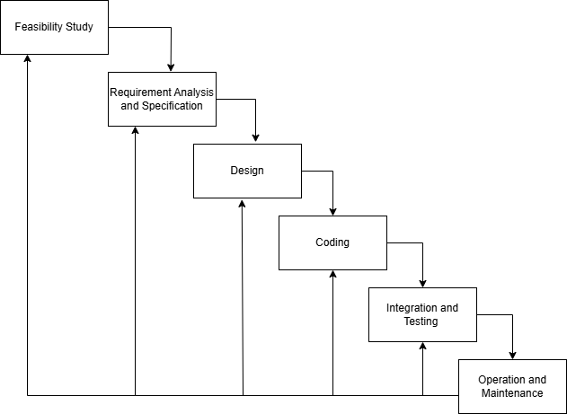
The Iterative Waterfall Model was adopted for the development of SajiloWear to ensure structured progress through each phase with continuous refinement. The process includes feasibility study, requirement analysis, system design, coding and testing, deployment, and maintenance, with payment system implementation and security considered throughout development.
Figure 1.1: Iterative Waterfall Model

Phases of the Iterative Waterfall Model
- Feasibility Study: Examined technical and economic aspects, confirming that open-source technologies like PHP, MySQL, and Bootstrap make the system cost-effective and feasible.
- Requirement Analysis: Gathered detailed requirements, focusing on user registration, rental process flow, payment management, and review system.
- System Design: Designed ER diagram, class diagram, and workflow diagrams to model the database and platform operations.
- Coding and Testing: Developed backend using PHP with MySQL for data storage, and frontend using HTML, CSS, and JavaScript for responsiveness. Conducted unit testing and integration testing to ensure functionality.
- Deployment: Tested locally using XAMPP and prepared for future deployment on a live server.
- Maintenance: Plan for regular updates to improve user experience, add payment gateways, and integrate delivery services in future iterations.

CHAPTER 2: BACKGROUND STUDY AND LITERATURE REVIEW

2.1 Background Study
Nepal is a country rich in cultural diversity and traditional attire, where clothing is not just a means of covering but a representation of heritage, ethnicity, and identity. Attire such as saree, lehenga, gunyo cholo, daura suruwal, and sherwani play an important role in major festivals, weddings, and cultural rituals. People invest a considerable amount of money to purchase these outfits, yet most of them are worn only once or twice.
Despite the significance of cultural attire, the fashion consumption pattern in Nepal is highly unsustainable. Clothes are bought for single-use events, stored away, and rarely worn again. This has led to wastage of resources, high financial burden on individuals, and underutilization of beautiful garments. Moreover, there is no centralized, structured, and user-friendly system to rent or share clothes digitally, which limits access for individuals who cannot afford to buy new outfits for every occasion.
Digital transformation in Nepal’s fashion industry is still in its early stages. While e-commerce platforms like Daraz have created a shift in buying behavior, online rental models remain largely unexplored. In this context, SajiloWear aims to bridge the gap between garment owners and renters by providing a peer-to-peer clothing rental platform. This platform not only reduces financial and environmental burden but also helps preserve Nepalese culture by encouraging more frequent use of traditional attire.
2.2 Literature Review
Globally, the clothing rental industry is witnessing rapid growth as part of the sharing economy. International platforms such as Rent the Runway (USA), Le Tote, and MyWardrobeHQ (UK) have proven that renting clothes online is an effective solution for affordability, sustainability, and style-conscious consumers. These platforms allow users to rent high-end fashion items for short durations, making luxury fashion accessible at a fraction of the cost.
In Nepal, however, digital clothing rental solutions are limited. Most existing rental services are operated by small local boutiques that require physical visits, advance booking through phone calls, and cash payments. There is little to no digital catalog management, real-time availability tracking, or secure transaction support. This creates a barrier for busy, urban customers who want a convenient, tech-enabled solution.
From a sustainability perspective, research published in the Journal of Fashion Marketing and Management shows that clothing rental and sharing platforms significantly reduce textile waste, carbon footprint, and overall garment overproduction [1]. Moreover, a report by the United Nations Environment Programme (UNEP) highlights that the fashion industry contributes nearly 10% of global greenhouse gas emissions, making sustainable fashion practices an urgent necessity [2].
Studies on peer-to-peer economy (like Airbnb and Uber) suggest that trust, transparency, and ease of use are critical for user adoption [3]. This insight is directly applicable to SajiloWear, which must focus on secure payments, verified users, clear rental terms, and robust review systems to build community trust.
Furthermore, consumer research shows that Gen Z and Millennials are highly receptive to fashion rental models because they value sustainability, affordability, and variety over permanent ownership [4]. This demographic trend indicates a strong market potential for SajiloWear among younger urban Nepali customers who want to look stylish for events but also remain budget-conscious.
Overall, the literature shows that SajiloWear is not only technologically feasible but also socially relevant, aligning with global sustainability trends and fulfilling an unmet need in the Nepali market.

CHAPTER 3: SYSTEM ANALYSIS AND DESIGN

3.1 System Analysis
System analysis examines the current process of acquiring traditional attire in Nepal and identifies the key challenges faced by users. The existing process largely involves purchasing expensive clothing from boutiques or markets, which leads to financial strain, underutilization of garments, and wardrobe waste. Occasional rental services exist, but they lack digital catalogs, secure transactions, and peer-to-peer connectivity.A structured system analysis ensures that SajiloWear delivers a scalable, secure, and user-friendly platform that benefits both garment owners and renters, while encouraging cultural preservation and reducing clothing waste.

3.1.1 Requirement Analysis
Requirement analysis identifies the main features and capabilities needed for SajiloWear to function effectively and fulfill user expectations. These requirements are divided into functional and non-functional categories.
i) Functional Requirements
- User Registration & Authentication: Users can create an account, log in securely using email/phone, and manage their profile. Owners and renters are verified to build trust and reduce fraud.
- Product Upload & Management: Garment owners can upload attire details, including images, size, price, and availability dates. They can also update or remove listings when required.
- Search&Filter: Users can browse products by category (saree, lehenga, daura suruwal, jewelry), price range, and availability for specific dates.
- RentalRequest&ApprovalSystem: Renters can request a product for a selected period. Owners receive notifications and approve or reject requests.
- Payment Integration: Secure payment options (cash on delivery, digital wallets) are supported. The system automatically calculates rental cost and commission for SajiloWear.
- Notifications & Alerts: Users receive updates on rental approval, upcoming return dates, and promotional offers.
- Ratings & Reviews: After returning an item, users can rate the owner/borrower and leave feedback to improve trust and reliability.
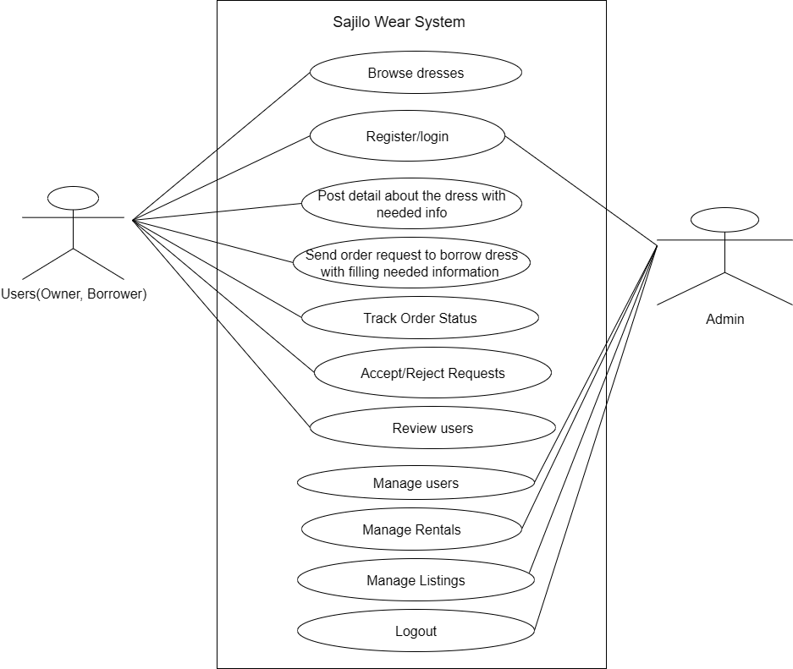
- Use Case Diagram

Figure 3.1: Use Case Diagram
ii) Non-Functional Requirements
- Security: All passwords are encrypted, and secure authentication is implemented to prevent unauthorized access.
- Scalability: The platform is designed to handle a growing number of users, product listings, and transactions without performance degradation.
- Usability: The interface is simple, responsive, and mobile-friendly to ensure smooth user experience even for first-time digital users.
- Performance Efficiency: Optimized database queries and image compression techniques are used to deliver fast page loads and smooth navigation.
- Reliability: The system ensures high uptime, proper session handling, and accurate data processing for rentals and payments.
- Maintainability: The codebase and database design are modular, making it easy to update or add new features like premium services or loyalty programs in the future.

3.1.2 Feasibility Analysis
Technical Feasibility: The system is built with PHP and MySQL, which are reliable, open-source, and widely supported technologies. Bootstrap and JavaScript ensure responsiveness and interactivity.
Economic Feasibility: The project has minimal cost, using free development tools (XAMPP, VS Code) and open-source libraries. Monetization is possible through commission per rental and premium listings.
Operational Feasibility: Users are already familiar with e-commerce workflows (like Daraz), so learning curve is minimal. Owners can easily upload pictures, and customers can easily browse and rent clothes.

3.1.3 Schedule Feasibility
A development schedule was created using a Gantt chart (Table 1) with phases for requirement gathering, design, coding, testing, and deployment. Each phase was given 2–3 weeks for proper completion.
Below is the Gantt chart that outlines the respective timelines.
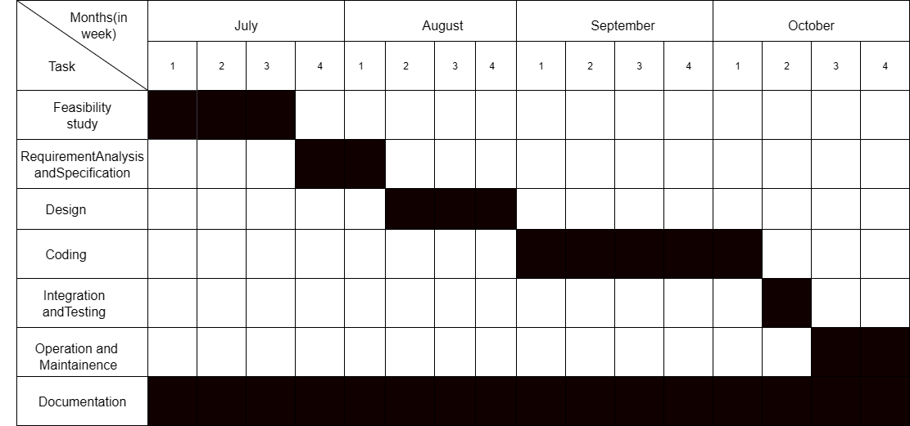
Table 1: Gantt Char

3.2 System Design
3.2.1 ER Diagram
An ER Diagram visually models a database's structure using entities (tables), attributes (fields), and relationships (connections). It shows how data links together through one-to-one, one-to-many, or many-to-many relationships, serving as a blueprint for efficient database design.
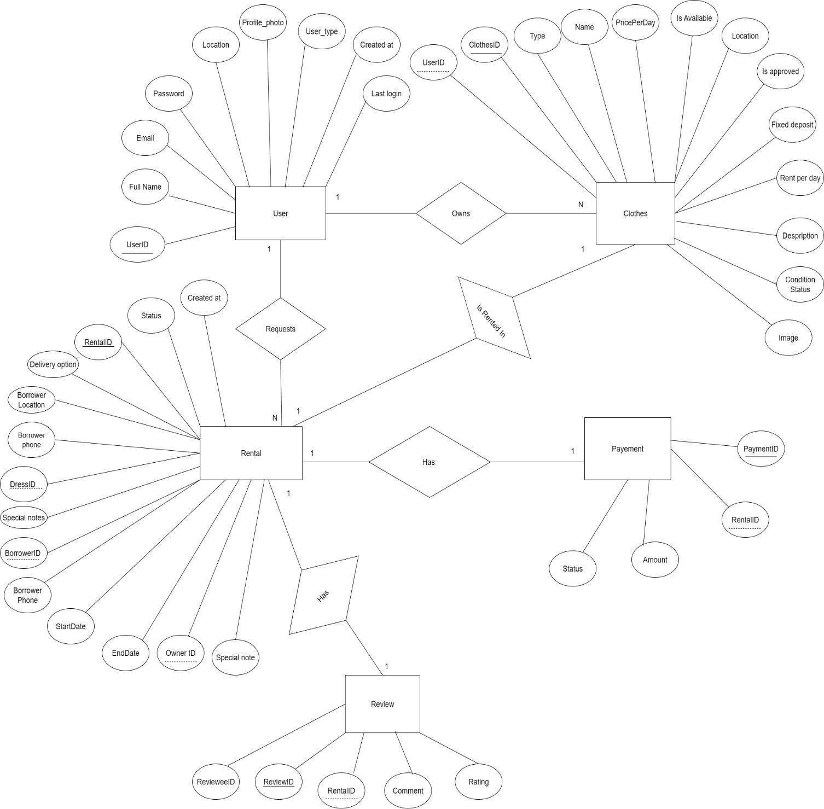
Figure 3.2: ER Diagram
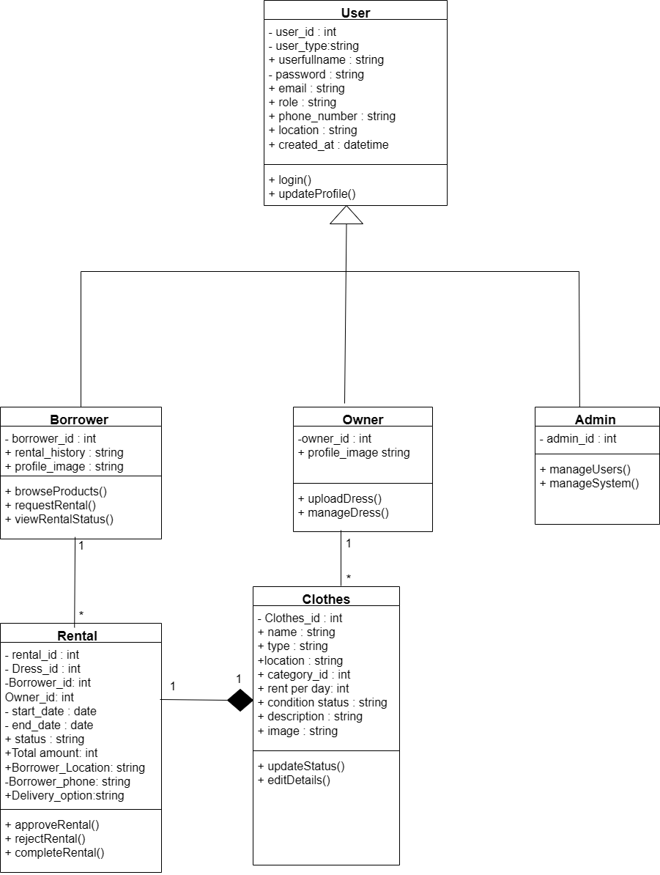
3.2.2 Class Diagram

Figure 3.3 : Class Diagram
Class Diagram for SajiloWear
The class diagram for SajiloWear represents the structural design of the system, showing how different components interact. It defines key entities such as User, Owner, Borrower, Admin, Dress, and Rental, and illustrates their relationships.

Key Relationships in the System
- User & Role (Generalization): The system uses inheritance where Owner, Borrower, and Admin are specialized subclasses of User. This allows all users to share common attributes like username, email, and password, while still performing role-specific actions such as uploading dresses (Owner), renting dresses (Borrower), or managing the platform (Admin).
- Owner & Dress (1-to-Many Association): Each Owner can upload multiple Dresses to the platform, but every Dress is associated with a single Owner.
- Borrower & Rental (1-to-Many Association): A Borrower can create multiple Rentals, but each Rental is linked to only one Borrower.
- Dress & Rental (Composition 1-to-1): A Rental cannot exist without a Dress. This is a composition relationship, meaning if the Dress is removed from the system, the corresponding Rental record is also deleted.
This class diagram provides a structured overview of how users, dresses, and rentals interact in the SajiloWear system. It ensures clarity in managing user roles, dress listings, rental workflows, and ownership, making the platform scalable and maintainable.

3.2.3 Sequence Diagram
A sequence diagram represents the flow of interactions between different components in a system over time.

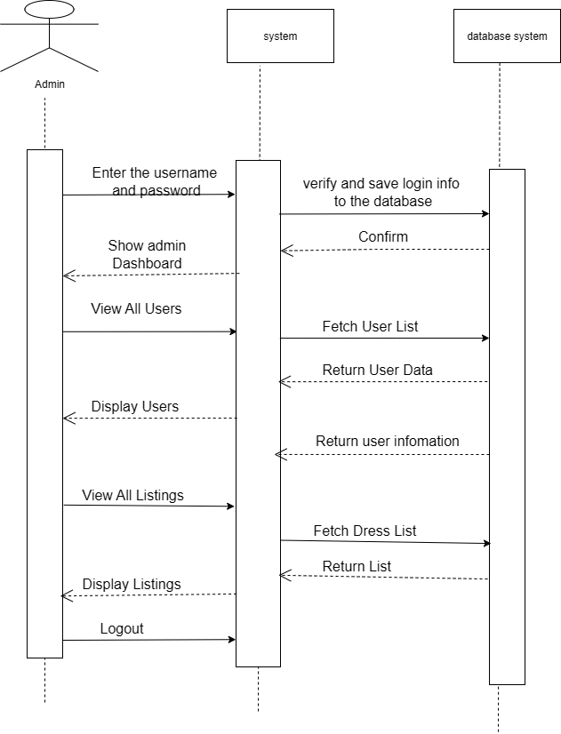
Figure 3. 4. Sequence Diagram of Admin

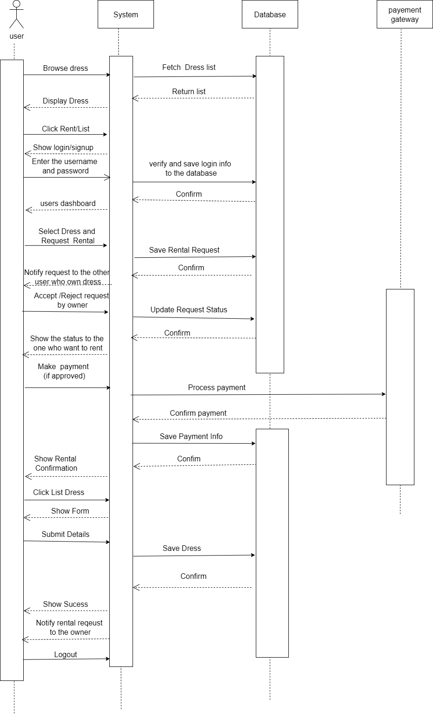
Figure 3.5: Sequence Diagram of User
3.2.4 Activity Diagram
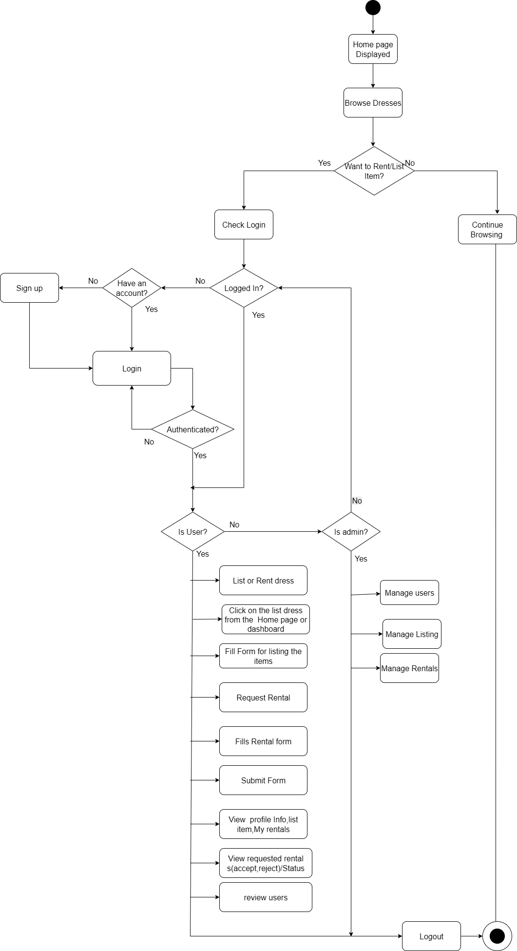
An activity diagram visualizes the step-by-step workflow of a process, showing decisions, parallel executions, and transitions between activities. It helps in analyzing business logic and improving process efficiency. These diagrams are useful for modeling dynamic aspects of a system.

Figure 3.5: Activity Diagram
CHAPTER 4: IMPLEMENTATION AND TESTING
4.1 Implementation
The implementation phase focused on building SajiloWear based on the structured system design created earlier. The goal was to create a functional and user-friendly platform where users can rent and borrow ethnic wear easily. Various tools and technologies were utilized to ensure efficient development, smooth testing, and proper deployment.
4.1.1 Tools Used
i. CASE Tools
- Draw.io:
Used for designing UML diagrams such as Use Case, Class, Sequence, and Activity diagrams. These diagrams helped in visualizing the renting process, user interactions, and the overall workflow of the system.
- Git & GitHub:
Version control and collaboration were managed through Git and GitHub. This helped in tracking changes to the code, maintaining multiple versions, and collaborating effectively during development.

ii. IDEs
- Visual Studio Code:
Used for writing and managing HTML, CSS, JavaScript, and PHP files. It provided a clean interface and extensions for faster development and debugging.
- XAMPP:
Used as the local development environment to host Apache server and MySQL database. It allowed smooth testing of backend functionality like user authentication, product upload, and rental flow before deployment to live hosting.

iii. Programming Languages
- PHP:
Used for backend development to handle server-side operations such as user authentication, product management, rental request processing, and database interactions.
- HTML, CSS, JavaScript:
Used for frontend development to design a simple, responsive, and interactive user interface. HTML was used for structuring pages, CSS for styling, and JavaScript for implementing dynamic functionality such as form validations and notifications.

iv. Database Platform
- MySQL:
Used for storing all structured data including user profiles, clothing products, rental requests, approvals, payments, and reviews. Proper indexing and relationships were applied to ensure data consistency and faster queries.

CHAPTER 5: CONCLUSION AND FUTURE RECOMMENDATION
5.1 Conclusion
SajiloWear provides an affordable and sustainable solution for renting traditional Nepali attire through a structured digital platform with payment integration.. It simplifies the process of browsing, renting, and sharing ethnic wear, ensuring that users can celebrate culture without financial strain. Owners can upload their attire, set availability, and approve rental requests, while borrowers can easily find and rent clothing for festivals, weddings, and events.By providing a well-structured system, SajiloWear promotes cultural preservation, reduces wardrobe waste, and encourages sustainable fashion practices. It bridges the gap between attire owners and borrowers, creating a community-driven marketplace that is affordable, accessible, and eco-friendly. This platform has the potential to bring traditional fashion closer to younger generations and inspire them to participate in cultural events.

5.2 Lesson Outcomes
Developing this project helped me strengthen my skills in web application development, particularly in building a strong backend with PHP and a responsive frontend using HTML, CSS, and JavaScript integrated with MySQL database. I learned how to implement user authentication, product upload modules, rental request flows, and notifications. Additionally, I gained hands-on experience working with XAMPP for local hosting, database design for storing user and product data, and designing clear system workflows using the Iterative Waterfall Model. Tackling real-world challenges like handling rental approvals, managing product availability, and ensuring security for users gave me valuable problem-solving experience and confidence in full-stack development.

5.3 Future Recommendation
To further improve the system, the following enhancements can be considered:
- Mobile Application: Develop a mobile app for Android/iOS to make renting and uploading attire more convenient for users on the go.
- Multiple Payment Gateway Integration: Enable various secure online payment options so users can choose their preferred method, ensuring smooth and reliable transactions.
- Recommendation System: Add AI-based recommendations to suggest outfits to users based on previous rentals and upcoming cultural events.
- Inventory Tracking: Provide owners with analytics on how many times their attire has been rented and their earnings.
- Delivery & Pickup Integration: Partner with local delivery services to streamline the handover and return process of rented attire.
- Multilingual Interface: Include support for multiple languages (Nepali, English, Newari) to make the platform more inclusive and user-friendly.
These improvements will enhance the overall usability, encourage higher adoption rates, and make SajiloWear a go-to solution for cultural attire rentals in Nepal.

REFERENCES
[1] A. Shrestha, "Digital Transformation in Nepal’s Fashion Industry," in 6th ICT Conference, Kathmandu, 2024.
[2] Fashion Nepal, "Sustainable Fashion and Rental Trends in Nepal," Fashion Nepal, 2025. [Online]. Available: https://fashionnepal.com/sustainable-fashion-rental-trends. [Accessed 26 4 2025].
[3] "Daraz Nepal," 15 March 2025. [Online]. [Accessed 26 4 2025].
[4] Statista, "Global Clothing Rental Market – Growth & Forecast 2023–2028," Statista, Berlin, 2024.
[5] T. Basnet, "Promoting Circular Economy through Clothing Rentals in Nepal," The Kathmandu Post, Kathmandu, 2023.

APPENDICES

